Cognitive Search Delivery Guide

Contents

[1.0 Deploy Services 2](https://microsoft.sharepoint.com/teams/DigitalCTO-AI-CognitiveSearch/Shared%20Documents/Pod/Delivery%20Guide/CognitiveSearchDeliveryGuide.docx#_Toc515973295)

[1.1 Azure Services 2](https://microsoft.sharepoint.com/teams/DigitalCTO-AI-CognitiveSearch/Shared%20Documents/Pod/Delivery%20Guide/CognitiveSearchDeliveryGuide.docx#_Toc515973296)

[1.2 ARM Template 2](https://microsoft.sharepoint.com/teams/DigitalCTO-AI-CognitiveSearch/Shared%20Documents/Pod/Delivery%20Guide/CognitiveSearchDeliveryGuide.docx#_Toc515973297)

[2.0 Ingest Documents 3](https://microsoft.sharepoint.com/teams/DigitalCTO-AI-CognitiveSearch/Shared%20Documents/Pod/Delivery%20Guide/CognitiveSearchDeliveryGuide.docx#_Toc515973298)

[3.0 Design Skillset 4](https://microsoft.sharepoint.com/teams/DigitalCTO-AI-CognitiveSearch/Shared%20Documents/Pod/Delivery%20Guide/CognitiveSearchDeliveryGuide.docx#_Toc515973299)

[4.0 Build Skills 5](https://microsoft.sharepoint.com/teams/DigitalCTO-AI-CognitiveSearch/Shared%20Documents/Pod/Delivery%20Guide/CognitiveSearchDeliveryGuide.docx#_Toc515973300)

[4.1 Build and train ML models 5](https://microsoft.sharepoint.com/teams/DigitalCTO-AI-CognitiveSearch/Shared%20Documents/Pod/Delivery%20Guide/CognitiveSearchDeliveryGuide.docx#_Toc515973303)

[4.2 Build Azure Functions 5](https://microsoft.sharepoint.com/teams/DigitalCTO-AI-CognitiveSearch/Shared%20Documents/Pod/Delivery%20Guide/CognitiveSearchDeliveryGuide.docx#_Toc515973304)

[5.0 Create Pipeline 6](https://microsoft.sharepoint.com/teams/DigitalCTO-AI-CognitiveSearch/Shared%20Documents/Pod/Delivery%20Guide/CognitiveSearchDeliveryGuide.docx#_Toc515973305)

[5.1 Define Data Source 6](https://microsoft.sharepoint.com/teams/DigitalCTO-AI-CognitiveSearch/Shared%20Documents/Pod/Delivery%20Guide/CognitiveSearchDeliveryGuide.docx#_Toc515973308)

[5.2 Define Index 6](https://microsoft.sharepoint.com/teams/DigitalCTO-AI-CognitiveSearch/Shared%20Documents/Pod/Delivery%20Guide/CognitiveSearchDeliveryGuide.docx#_Toc515973309)

[5.3 Define Skillset 6](https://microsoft.sharepoint.com/teams/DigitalCTO-AI-CognitiveSearch/Shared%20Documents/Pod/Delivery%20Guide/CognitiveSearchDeliveryGuide.docx#_Toc515973310)

[5.4 Define Indexer 7](https://microsoft.sharepoint.com/teams/DigitalCTO-AI-CognitiveSearch/Shared%20Documents/Pod/Delivery%20Guide/CognitiveSearchDeliveryGuide.docx#_Toc515973311)

[5.5 Verify Index Content 7](https://microsoft.sharepoint.com/teams/DigitalCTO-AI-CognitiveSearch/Shared%20Documents/Pod/Delivery%20Guide/CognitiveSearchDeliveryGuide.docx#_Toc515973312)

[6.0 Deploy UI 8](https://microsoft.sharepoint.com/teams/DigitalCTO-AI-CognitiveSearch/Shared%20Documents/Pod/Delivery%20Guide/CognitiveSearchDeliveryGuide.docx#_Toc515973313)

[6.1 Update Configuration 8](https://microsoft.sharepoint.com/teams/DigitalCTO-AI-CognitiveSearch/Shared%20Documents/Pod/Delivery%20Guide/CognitiveSearchDeliveryGuide.docx#_Toc515973314)

[7.0 Additional Resources 10](https://microsoft.sharepoint.com/teams/DigitalCTO-AI-CognitiveSearch/Shared%20Documents/Pod/Delivery%20Guide/CognitiveSearchDeliveryGuide.docx#_Toc515973315)

[7.1 Supporting Documents 10](https://microsoft.sharepoint.com/teams/DigitalCTO-AI-CognitiveSearch/Shared%20Documents/Pod/Delivery%20Guide/CognitiveSearchDeliveryGuide.docx#_Toc515973316)

[7.2 Relevant Azure Documentation 10](https://microsoft.sharepoint.com/teams/DigitalCTO-AI-CognitiveSearch/Shared%20Documents/Pod/Delivery%20Guide/CognitiveSearchDeliveryGuide.docx#_Toc515973317)

# Deploy Services

## Azure Services

|  |  |
| --- | --- |
| [Azure Search Service](https://azure.microsoft.com/en-us/services/search/) | The hosting service for your Search Index, Cognitive Skillset, and Search Indexer |
| [Azure Storage Account](https://azure.microsoft.com/en-us/services/storage/) | The primary data store for the ingested files |
| [Azure Functions App](https://azure.microsoft.com/en-us/services/functions/) | The hosting service for your custom skills, as well as the ingest function |
| [Azure ML](https://azure.microsoft.com/en-us/services/virtual-machines/data-science-virtual-machines/) | Telemetry monitoring service for the Search UI |
| [Web App](https://azure.microsoft.com/en-us/services/app-service/web/) | The hosting service for the Search UI |
| [Application Insights](https://azure.microsoft.com/en-us/services/application-insights/) | Telemetry monitoring service for the Search UI |
| [Azure AD](https://azure.microsoft.com/en-us/services/active-directory/) | Active Directory for managing user profiles and search history |

## ARM Template

You can deploy your Azure Resources more easily using the pre-configured ARM template included with this documentation here: ARM Template. Modify the parameters file to configure the names of your resources (resource names should be lowercased). Then deploy using the deploy PowerShell script. Find more information on deploying ARM templates here: <https://docs.microsoft.com/en-us/azure/azure-resource-manager/resource-group-template-deploy-portal>.

# Ingest Documents

To use Cognitive Search, you should first ingest your raw files into a storage location, such as Azure Blob Storage or Cosmos DB. Depending on your data structure, you may want to combine additional metadata with your extracted content to enable more advanced search scenarios. This can be achieved using a custom skill in your Cognitive Search pipeline and will be discussed further in later sections.

For the purposes of this guide we will be using Azure Blob Storage as our primary storage location.

# Design Skillset

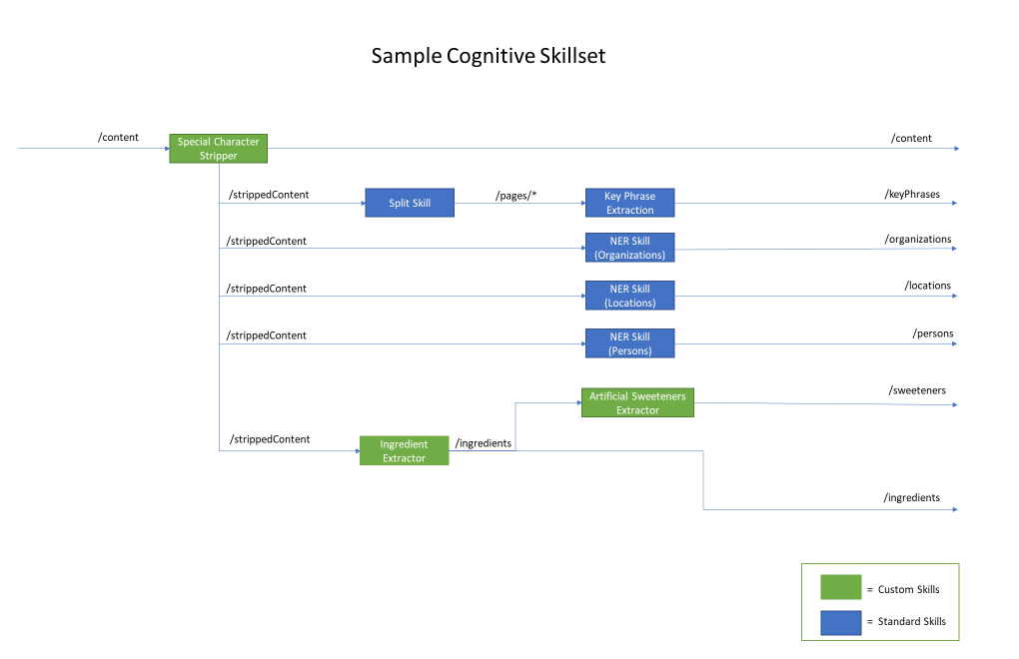

# Build Skills



## Build and train ML models

Custom Skills in Cognitive Search allow for additional defining and processing of file data. There is no set definition of what these skills can do, but some examples include extracting unsupported entities or complex types, storing file content externally, or performing predictive analysis using a model. These custom skills can be chained together or with the standard Cognitive Services skills, such as the Named Entity Recognition (NER) skills. As mentioned before, additional processing of the file data might be required prior to using the standard Cognitive Services skills, such as removing special characters for better accuracy and relevance.

These Custom Skills can be hosted on an Azure Function for easy API integration within the Cognitive Search Pipeline.

In the diagram below you can see an example of a Cognitive Search skillset that uses both standard and Custom Skills. This example scenario highlights the use of Custom Skills that feed into the standard Cognitive Services skills. You can imagine that this scenario is for a food company that wants to search through their documents for specific entities, such as ingredients or its facilities in various locations.

## Build Azure Functions

Azure Functions are a simple way to deploy custom skills and can be integrated with your Cognitive Search pipeline using the WebApiSkill.

# Create Pipeline



## Define Data Source

Create data source (Azure Search REST API)

PUT /datasources/{{data-source}}?api-version=2017-11-11-preview HTTP/1.1

Host: {{search-service}}.search.windows.net

api-key: {{search-api-key}}

Content-Type: application/json

Body: [Deployment/create_data_source.json](https://microsoft.sharepoint.com/teams/DigitalCTO-AI-CognitiveSearch/Shared%20Documents/WK/WKHandoffDocs/Deployment/create_data_source.json)

## Define Index

Define your index fields ([Read more](https://docs.microsoft.com/en-us/azure/search/search-create-index-portal))

Create Search Index (Azure Search REST API)

PUT /indexes/{{search-index}}?api-version=2017-11-11-preview HTTP/1.1

Host: {{search-service}}.search.windows.net

api-key: {{search-api-key}}

Content-Type: application/json

Body: [Deployment/create_index.json](https://microsoft.sharepoint.com/teams/DigitalCTO-AI-CognitiveSearch/Shared%20Documents/WK/WKHandoffDocs/Deployment/create_index.json)

## Define Skillset

Define Cognitive Skillset ([Read more](https://docs.microsoft.com/en-us/azure/search/cognitive-search-tutorial-blob))

Create Cognitive Skillset (Azure Search REST API)

PUT /skillsets/{{search-chained-skillset}}?api-version=2017-11-11-preview HTTP/1.1

Host: {{search-service}}.search.windows.net

api-key: {{search-api-key}}

Content-Type: application/json

Body: [Deployment/create_skillset.json](https://microsoft.sharepoint.com/teams/DigitalCTO-AI-CognitiveSearch/Shared%20Documents/WK/WKHandoffDocs/Deployment/create_skillset.json)

## Define Indexer

Define Search Indexer ([Read more](https://docs.microsoft.com/en-us/azure/search/cognitive-search-tutorial-blob))

Create and Run Indexer (Azure Search REST API)

PUT /indexers/{{search-indexer}}?api-version=2017-11-11-preview HTTP/1.1

Host: {{search-service}}.search.windows.net

api-key: {{search-api-key}}

Content-Type: application/json

Body: [Deployment/create_indexer.json](https://microsoft.sharepoint.com/teams/DigitalCTO-AI-CognitiveSearch/Shared%20Documents/WK/WKHandoffDocs/Deployment/create_indexer.json)

## 5.5 Verify Index Content

Verify index content (Azure Search REST API)

GET /indexes/{{search-index}}/docs?search=*&amp;api-version=2017-11-11-Preview HTTP/1.1Host: {{search-service}}.search.windows.net

api-key: {{search-api-key}}

Content-Type: application/json

Body: [Deployment/sample_index_search.json](https://microsoft.sharepoint.com/teams/DigitalCTO-AI-CognitiveSearch/Shared%20Documents/WK/WKHandoffDocs/Deployment/sample_index_search.json)

# Deploy UI

## Update Configuration

Listed below are the various locations where you can customize where you can set your UI generated fields, index, telemetry service, and other services.

Search Model

The file SearchModel.cs has three settings that can be customized: facets, tags, and which fields will be shown on the results page. The UI will take these values and generate HTML scripts that display reflect these settings.

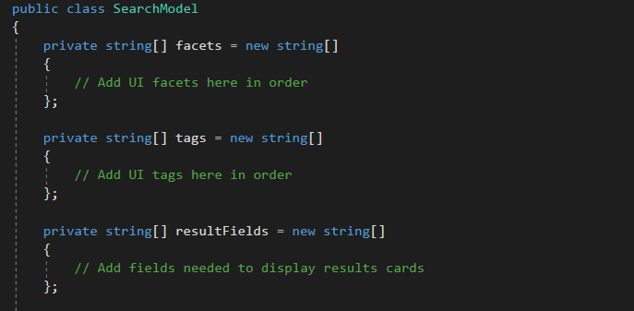

### 

Configuring Azure Search index

1. Update the DocumentSearchClient.cs, fields with desired search service, API key, and index name

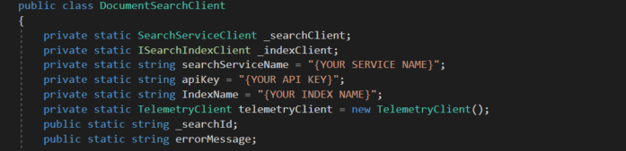

Configuring App Insights

1. In _Layout.cshtml, change the Instrumentation Key to the appropriate one found at Search Service -> Search traffic analytics. This instance of the Instrumentation Key will be used to track all document access.

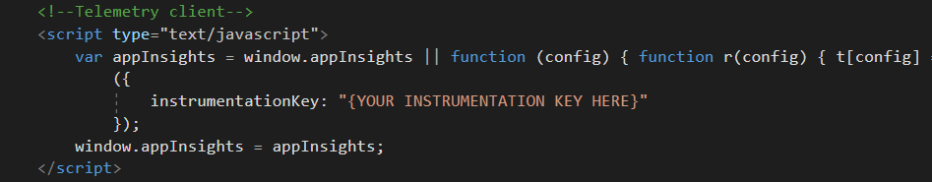

1. In DocumentSearchClient.cs, change the Instrumentation Key to the same one used above at Search Service -> Search traffic analytics. This telemetry client will track all searches.

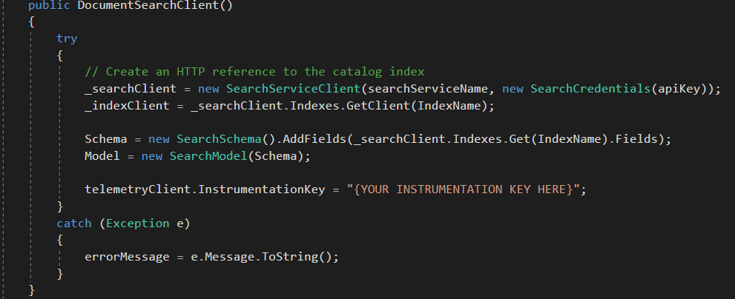

Other UI Configurations

Authenticated experience with search history

1. Create SQL DB (See [sqlDBScripts.sql](http://sqlDBScripts.sql))
   1. User - User account information
   2. Search – User search history
   3. Document - User’s document viewing history
2. Create Azure AD instance
   1. Configure Azure AD instance ([Read more)](https://docs.microsoft.com/en-us/azure/active-directory/develop/active-directory-integrating-applications)
      1. Be sure to add the correct Reply URLs for both local and hosted app testing
   2. Integrate Azure AD V2 into ASP.NET Core web app ([Read more](https://azure.microsoft.com/en-us/resources/samples/active-directory-aspnetcore-webapp-openidconnect-v2/))
      1. Adding and configuring the Extensions files, Startup.cs file, Account Controller, and Views are the main points
3. Update web app with connection information – appsettings.json

# Additional Resources

## 7.1 Supporting Documents

|  |  |
| --- | --- |
| Source Code |  |
| Postman Collection | [CognitiveServicesTemplate_PostmanCollection.zip](https://microsoft.sharepoint.com/teams/DigitalCTO-AI-CognitiveSearch/Shared%20Documents/Pod/Delivery%20Guide/CognitiveServicesTemplate_PostmanCollection.zip) |
| Skillset Diagram | [SampleCognitiveSkillset.pptx](https://microsoft.sharepoint.com/teams/DigitalCTO-AI-CognitiveSearch/Shared%20Documents/Pod/Delivery%20Guide/SampleCognitiveSkillsetDiagram.pptx) |
| ARM Template | [template.json](https://microsoft.sharepoint.com/teams/DigitalCTO-AI-CognitiveSearch/Shared%20Documents/Pod/Delivery%20Guide/ARM%20Template/template.json) |

## 7.2 Relevant Azure Documentation

|  |  |
| --- | --- |
| Creating Azure Search Service | [Read more](https://docs.microsoft.com/en-us/azure/search/cognitive-search-quickstart-blob) |
|  |  |
|  |  |
|  |  |